**Who: LE Officers**

**What**: 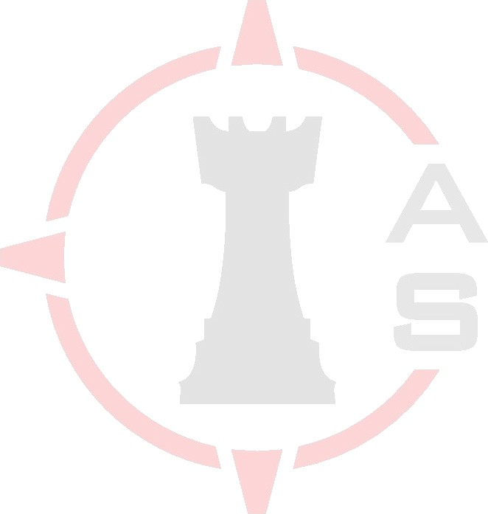Tactical Combat Casualty Care Seminar

**When**: September 20, 2024

**Where**:

* Asymmetric Solutions, 410 Thomas Rd., Farmington, MO 63640

**Purpose**: Increase survivability of LE Officers, enhance decision making process iin a dynamic environment.

**Logisitcs:**

* Training Munitions, small arms
  + Pistol: 50

Gear: Full Shooters Kit, Weapons, Gloves, Eye Pro, Ear Pro, Med kit

**(2) Sessions** [4 hrs. ea.]

**Session 1**

* 0800-0830 Administrative processing / Introductions
* 0830-1000 Basic TCCC Overview
* 1000-1200 Scenrios
* 1200- ENDEX/Debrief

**Session 2**

* 1300-1330 Administrative processing / Introductions
* 1330-1500 Basic TCCC Overview
* 1500-1700 Scenarios
* 1700- ENDEX/Debrief

**Registration:** Please submit enrollment form to Asymmetric Solutions 271 W. 1st St. Eureka, Mo. 63025 (Attn: Nancy J.) or email to [info@asusa1.com](mailto:info@asusa1.com)

**For questions please contact:**

Erik Poulin - Vice President of Law Enforcement Operations

[erikp@asusa1.com](mailto:erikp@asusa1.com)